Benchmarking: Dry Cleaner

A dry cleaner layout is usually designed to optimize employee productivity and space use efficiency through planning the arrangement of equipment and the flow of work. In this situation, the use of automated transmission machines is adapted to transport, sort, and store garments.

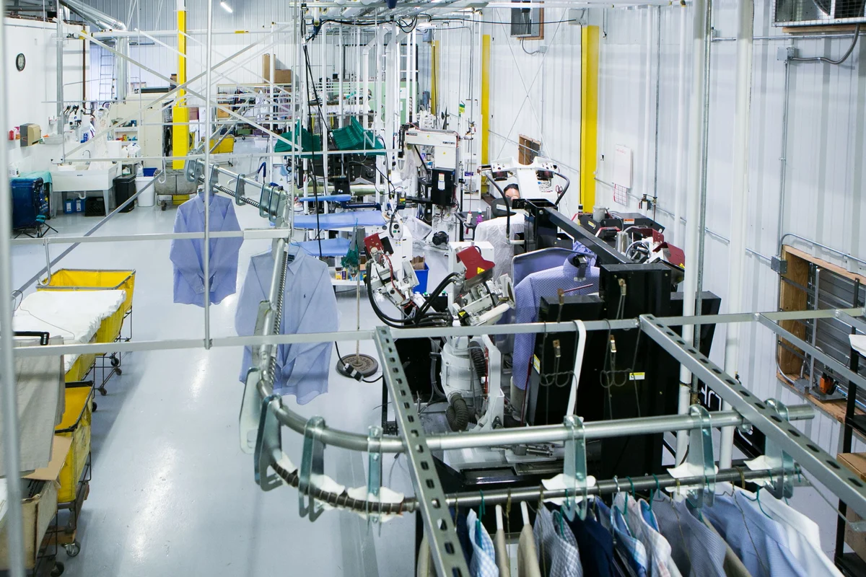

Figure X. Display of clothes on rack of dry cleaning system

Solution

Automated Transmission Machine (Automated Garment Conveyor System)

Description

This system consists of a motorized conveyor track equipped with hooks or slots where garments can be hung and automatically moved to different stations for processing or storage.This technology allows dry cleaners to manage a great amount of clothing items in an orderly and efficient manner.

Table X. *Pros and Cons of Dry Cleaner solution.*

| Pros | Cons |
| --- | --- |
| * Saves space from the remove of the need to walk around through each cabinet * Easily access any storage unit through the hold of a button | * Could be costly due to springs and levers that require metal parts * Requires mechanical energy to operate * Requires regular maintenance updates and check ups |

Table X. *Space Objective Assessment.*

| **Space Objectives** | Goals and Description |
| --- | --- |
| Maximize utilization of space | Saves walking space in storage room as system uses rotational space |
| Adaptable furniture | This solution is to be incorporated into the storage room directly |

Table X*. Storage Objective Assessment.*

| **Storage Objectives** | Goals and Description |
| --- | --- |
| Durable and Robust | The material of this transmission system should be stiff enough and requires constant maintenance. |
| Secure | These cabinets are stored so close to each other that it is impossible to open until withdrawn from the machine, the button to cycle cabinets will have a lock |
| Flexible | Users get easy access to specific clothing wherever it is stored with the automatic transmission system |

Conclusion (comparison)

The use of Automated Transmission System in a Dry Cleaner aims to optimize the utilization of limited space and increase efficiency in retrieving items, which is exactly the same need for the Clubhouse redesign. But this system requires a high building cost and is probably still too large for the storage room size provided in Clubhouse.